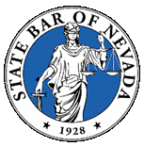 | State Bar of Nevada – Construction Law Section  August 20, 2015 Board Meeting

2014 Board:
Michael Kimmel, Chair (mkimmel@nevadalaw.com)
Casey Quinn, Vice Chair (casey.quinn@ndlf.com)
Carolyn Renner, Treasurer (crenner@mclrenolaw.com)
Michael Wadley, Secretary (mwwadley@hollandhart.com)

I. Treasurer's Report (Renner):
Available Balance $21,012.30.
II. Chair Update (Kimmel/Renner):
A. Discussions related to CLE
November 4th from 12-2 lunch provided.
Talk about annual meeting next month.

IV. Next Board Meeting – September 24, 3:00 p.m.
A. Annual meeting
B. CLE
C. Annual budget

