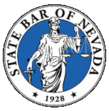 | State Bar of Nevada – Construction Law Section  July 23, 2015 Board Meeting

2015 Board:
Michael Kimmel, Chair (mkimmel@nevadalaw.com)
Casey Quinn, Vice Chair (casey.quinn@ndlf.com)
Carolyn Renner, Treasurer (crenner@mclrenolaw.com)
Michael Wadley, Secretary (mwwadley@hollandhart.com)

I. Treasurer's Report (Renner):
Available Balance $20,401.52.
II. Chair Update (Kimmel/Renner):
A. State bar convention update
a. 60 or 70 attended. Not many questions were asked. Only had an hour.
b. We have a CLE topic on AB 125.
Three hour program.
B. Talk about upcoming elections.
IV. Next Board Meeting – August 20, 2015 at 3:00 p.m.

