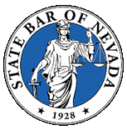 | State Bar of Nevada – Construction Law Section  May 21, 2015 Board Meeting

2014 Board:
Michael Kimmel, Chair (mkimmel@nevadalaw.com)
Casey Quinn, Vice Chair (casey.quinn@ndlf.com)
Carolyn Renner, Treasurer (crenner@mclrenolaw.com)
Michael Wadley, Secretary (mwwadley@hollandhart.com)

I. Treasurer's Report (Renner):
Available Balance $20,712.58.
II. Chair Update (Kimmel/Renner):
A. General Discussions regarding upcoming Bar meeting
a.
IV. Next Board Meeting – July 16, 2015 at 3:00 p.m.

